Pakistan J. Zool., vol. 43(3), pp. 587-592, 2011.

Molecular Identification and Haematological Values of Strangles (Streptococcus equi) Affected Mules in Pakistan

Muhammad Ijaz*, Muhammad Sarwar Khan, Muhammad Arif Khan, Muhammad Avais, Muhammad Muddassir Ali and Muhammad Hassan Saleem
Department of Clinical Medicine and Surgery University of Veterinary and Animal Sciences Lahore, 54000, Punjab, Pakistan.

Abstract.- Streptococcus equi serovar equi (S. equi) causes strangles, a highly contagious purulent lymphadenitis and pharyngitis of members of the family Equidae. The occurrence of S. equi in nasal discharges and pus from sub-mandibular lymph nodes in mules at Lahore and Sargodha districts of Punjab province were studied, and total white blood cells (WBCs), mean segmental neutrophil count (MSNC), lymphocytes, monocytes, eosinophils, basophils, erythrocytes, packed cell volume and haemoglobin measured at 1, 2, 3, and 4 weeks following the onset of strangles infection. A total of 188 nasal swabs and 62 pus samples were collected and examined; 113 (45.2%) were positive for S. equi. A higher occurrence of S. equi was recorded in mules <2 years of age compared to >2 years. Total WBCs, MSNC, and monocytes were significantly increased (P < .05), while the concentration of lymphocytes significantly decreased (P < .05) in infected mules.

Keywords: Mules, strangles, Streptococcus equi.

INTRODUCTION

Streptococcus equi, the causative agent of equine strangles, is shed in nasal discharges and pus from lymph nodes of affected animals. Routine laboratory detection of the organism involving culture of nasal swabs and pus from abscesses is often difficult because of background contamination. Culture and identification usually takes 2-3 days, an excessively lengthy interval given the highly contagious nature of strangles and the need to quickly identify the shedding animals so that they may be isolated in the early stages of an outbreak (Timoney and Artiushin, 1997).
The symptoms become apparent after an incubation period of 3 to 8 days, and the clinical course usually lasts 3 to 4 weeks (Piche, 1984; Yelle, 1987; Clabough, 1987; Nara et al., 1983). Marked fever (103-106°F) develops during the acute phase and may subside until the lymph nodes abscess, at which time a second wave of fever may develop. Affected horses typically become anorexic, depressed, and develop bilateral, serous to mucoid nasal discharge within 24 hours of onset of fever. The discharge becomes mucopurulent as the disease
__________________________
* Corresponding author. dr_ijaz07@yahoo.com
0030-9923/2011/0003-0587 $ 8.00/0
Copyright 2011 Zoological Society of Pakistan.
progresses, and a moist cough may develop in some cases. Plasma fibrinogen concentration and leukocyte counts usually increase at this time. The submandibular lymph nodes are involved most often and become enlarged, firm, and painful. The retropharyngeal lymph nodes may also be affected, and can induce dysphagia if they become markedly enlarged. The abscessed lymph nodes typically rupture 7 to 10 days after the onset of clinical signs and, in uncomplicated cases; recovery is complete 1 to 2 weeks thereafter (Reed et al., 2004).
Due to rapidity, sensitivity, and specificity, Polymerase Chain Reaction (PCR) techniques are increasingly being used to diagnose bacterial diseases of equines (Anzai et al., 1999, 2002). A PCR method targeting the S. equi-specific gene SeM (a cell wall associated protein) known to be a major virulence factor and protective antigen of S. equi (Boschwitz and Timoney, 1994; Meehan et al., 2000; Timoney et al., 1997) has been developed to overcome the drawbacks of the bacterial isolation method, and its usefulness in the diagnosis of strangles has been reported (Newton et al., 2000; Timoney and Artiushin, 1997; Verheyen et al., 2000). The primer for this PCR test was designed on the variable portion of the SeM gene (Anzai et al., 2005)
Changes in hematological parameters, such as total and differential white cell counts have been recorded in horses naturally and experimentally infected with S. equi (Hamlen et al., 1994). Blood neutrophil counts were performed on a group of naturally infected horses in another study (Dalgleish et al., 1993). Hematological values have been studied from horses experimentally infected with S. equi (Knight et al., 1975; Nara et al., 1983). Total white cell counts in horses on days 2, 5, 10, 15, and 20 following experimental infection were conducted (Nara et al., 1983).
A considerable literature is available on S. equi in most of the world’s horse raising communities, but very little information on this pathogen in mules has been published. This study describes the occurrence of S. equi and its effect on hematological values in mules showing clinical signs of strangles in the Lahore and Sargodha districts of Punjab province, Pakistan and provides baseline data for further work on S. equi in mules.

MATERIALS AND METHODS

Two equine rearing districts of Punjab, including Lahore and Sargodha were surveyed monthly in 2009 for new cases of strangles in mules. Fever, cough, purulent nasal discharge, enlargement of sub-mandibular lymph nodes, increased respiration rate, loss of appetite, and abnormal auscultation of trachea and thoracic cavity were the main symptoms (Merchant and Packer, 1983). A total of 188 samples of nasal discharge and 62 pus samples from affected sub-mandibular lymph nodes were collected from diagnosed mules. Samples were processed at microbiology laboratories at the University of Veterinary and Animal Sciences, Lahore, Pakistan and the Gluck Equine Research Center, University of Kentucky, USA.

Isolation of S. equi and DNA extraction
Samples were cultured on blood agar plates and incubated at 37°C for 24 h under anaerobic conditions (Jorm, 1990). Typical beta hemolytic streptococci-like colonies were detected on blood agar and identified by characteristic colony morphology, Gram staining, and biochemical tests, including catalase. Isolates identified as S. equi fermented salicin and sucrose, but not lactose, sorbitol, trehalose (Quinn et al., 1994). The DNA from S. equi samples was extracted using the Genomic Purification Kit (Fermentas* #K0512). Ten to twenty mg of bacterial (S. equi) culture was suspended in a 1.5 ml eppendorf tube containing 200 µl TE buffer and 400 µl of lysis solution, incubated at 65ºC for 5 min in a water bath with slight shaking. Then 600 µl chloroform was added and centrifuged at 10,000 rpm for 2 min. The upper aqueous phase solution containing DNA was transferred to a fresh tube and 800 µl precipitation solutions was added, mixed at room temperature for 1-2 min and centrifuged at 10,000 rpm for 2 min. The supernatant was removed and the DNA pellet dissolved in 100 µl of 1.2M NaCl solution. The pellet was completely dissolved and 300 µl chilled absolute ethanol added to precipitate DNA (10 min at -20ºC) and centrifuged again at 10,000 rpm for 6-8 min. The supernatant was discarded and the pellet washed once with 100 µl 70% ethanol, allowed to dry completely, and dissolved in 100 µl of double distilled deionized water. The DNA samples were allotted the laboratory DNA number and stored at -20°C.

Polymerase chain reaction
The forward primer KPF (5´-TGCATAAAGAAGTTCCTGTC) and reverse primer KPR (5´-GATTCGGTAAGAGCTTGACG) described (Newton et al., 2000; Timoney and Artiushin, 1997) were used to PCR amplify 677 bp of N terminal region of the SeM gene unique to S. equi using ThermoJet Thermocycler. Cycling was as follows: 94°C for five min, 94°C for 1 min, 56°C for 1 min, and 72°C for 2 min, repeated 30 times; 72°C for ten min; and 4°C final. The PCR products were separated by ethidium bromide agarose gel electrophoresis.

Haematological examination
Twenty mules out of 113, affected with strangles were selected for hematological examination and compared with 20 healthy mules. A 5 ml blood sample was collected at weekly intervals directly from the jugular vein of S. equi affected mules into sterilized plastic bottles with anticoagulant coated with EDTA at 1 mg/ml of blood. Total white blood cell count (WBC), mean segmented neutrophil count (MSNC), total lymphocye count, total monocyte count, total eosinophil count, total basophil count, total erythrocyte count (EC), packed cell volume (PCV), and hemoglobin (Hb) concentration were estimated using a haematological analyser.

Table I.- Overall prevalence of Streptococcus equi isolated from nasal discharge and pus of sub-mandibular lymph nodes in mules.

Age (Years) | n | Number positive for S. equi |  |  |  |  |  |  |  |  |  |  | Total (%)
Age (Years) | n | January |  | February |  | March |  | April |  | May |  | June-December | Total (%)
<1 | 50 | 01 |  | 07 |  | 12 |  | 18 |  | 06 |  | 0 | 44(88%)
1-2 | 50 | 00 |  | 08 |  | 11 |  | 19 |  | 04 |  | 0 | 42(84%)
2-3 | 50 | 00 |  | 02 |  | 04 |  | 05 |  | 02 |  | 0 | 13(26%)
3-4 | 50 | 00 |  | 01 |  | 02 |  | 04 |  | 01 |  | 0 | 08(16%)
4-5 | 50 | 00 |  | 02 |  | 01 |  | 03 |  | 00 |  | 0 | 06(12%)
Total | 250 | 01 |  | 20 |  | 30 |  | 49 |  | 13 |  | 0 | 113(45.2)

Statistical analysis
Data regarding occurrence of S. equi were evaluated using the χ² test, and data on haematology were analyzed with one way ANOVA. The differences between diseased and healthy mules at different weeks were assessed by Tukey’s test. A P-value < .05 was used to reject the null hypothesis.

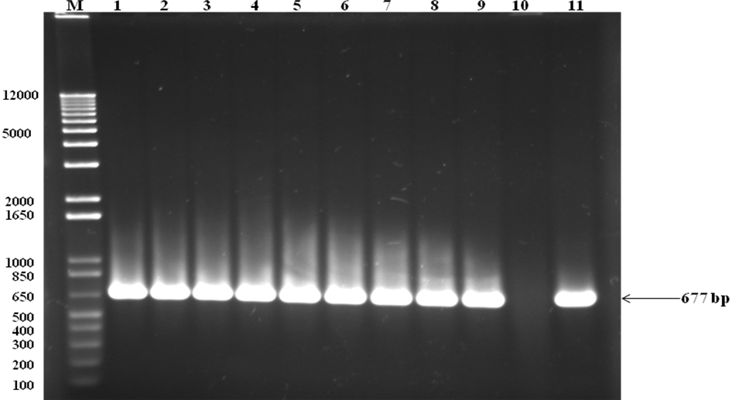

Fig. 1. PCR amplification of DNAs from mules isolates of S. equi with specific primers. Lanes 1 -9 show the PCR products of S. equi with sized 677 bp by using SeM primers. Lane 10 and 11 serve as -ve control and +ve control (CF32, S. equi, USA,) respectively.

RESULTS AND DISCUSSION

Molecular identification
The data on occurrence of S. equi is shown in Figure 1 and Table I. Of 250 mules, 113 (45.2%) were found positive for S. equi and the strangles were observed in all age groups from January to May. Our findings are in agreement with the results of Manzoor et al. (2008) who reported incidence of strangles and occurrence of Streptococcus species in strangles-infected foals of 9 months to 2 years of age throughout the year and found the highest occurrence during spring (mid January to beginning of May). It was observed that the number of S. equi isolates was significantly higher (P < .05) in pus samples from sub-mandibular lymph nodes as compared to nasal discharge samples. There were significant differences (P < .05) among mules of different age groups. Our results are consistent with those of Ijaz et al. (2010) who reported 82% strangles in mules <1 years of age, 78% in those from 1-2 years, 20% from 2-3 years, 12% from 3-4 years, and 6% from 4-5 years, in Pakistan. Ashraf (2000) has reported 33.2% strangles in mules of less than 2 years of age and 35.4% in mules of more than 2 years of age, in Pakistan. Sweeney et al. (1989) found rates of S. equi infections of the upper respiratory tract and lymph nodes (strangles) in horses to be 47.5% in 1 year old horses, and 37.5% in foals. S. equi subsp. equi was isolated from nasal, pharyngeal, or lymph node specimens in 31 (60.8%) of 51 sick horses. Halmen et al. (1994) reported foals highly susceptible to developing strangles following S. equi subsp. equi exposure as shown by rates of 86% (19/22) and 91% (10/11), respectively.

Haematological values of mules
In the present study, total WBCs, MSNC and monocytes were significantly increased (P < .05), whereas the concentration of lymphocytes was significantly decreased (P<.05) in infected mules. The Hb and PCV, non-significant decrease (P>.05) (Table II). Our results correlate with the findings of Gomez (1990) who recorded leukocytosis with counts upto 30,000/µL and MSNC upto 25,000/µL. Leukocytosis and neutophilia were also observed in the foal experimentally inoculated with S. equi and have been
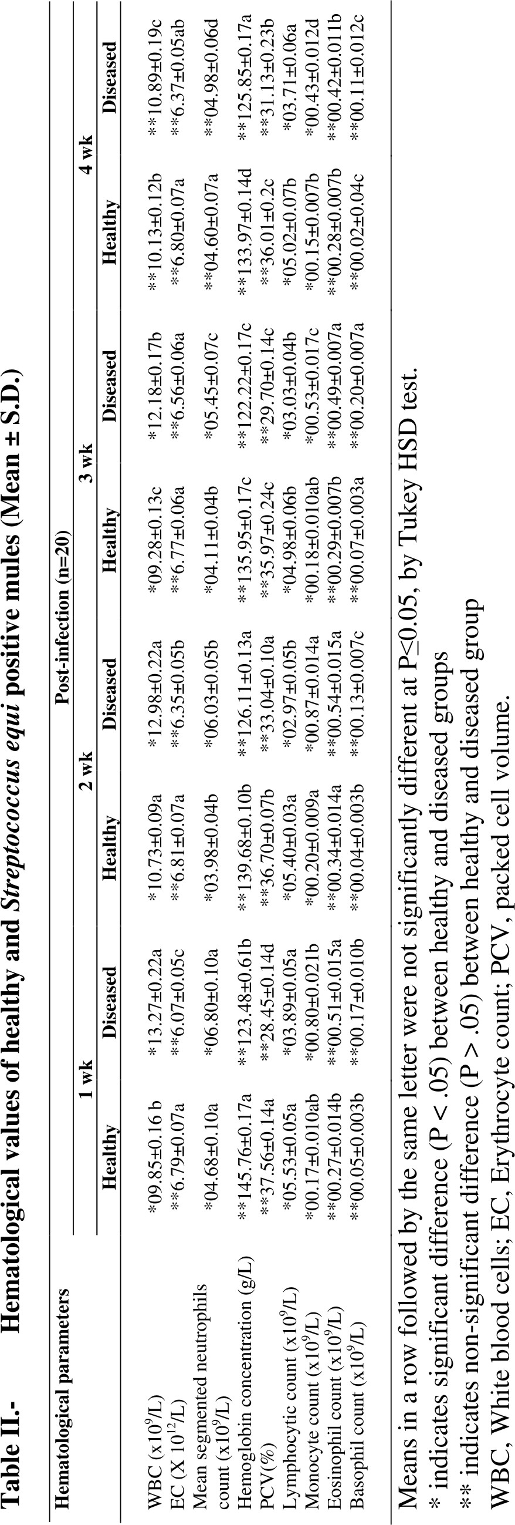
reported by others following experimental S. equi infections (Evers, 1968; Knight et al., 1975; Nara et al., 1983; Higgins and Snyder, 2006; Helmen et al., 1994). Other blood parameters including total eosinophilic count, total basophilic count, total EC, PCV, and Hb concentration remained non significant (P>0.05) during the four weeks post infection. The result of this study was also in line with Mahaffey (1962) and Halmen et al. (1994) Halmen et al. (1994) have also reported that strangles cases had lower mean PCV and Hb concentration than non infected animals during weeks 4, 6 and 10 of the outbreak. The EC was also lower in cases compared to non infected animals during weeks 6 and 10. Collins and Wernery (1999) reported that a complete blood count proved to be a useful adjunctive test to support a diagnosis of S equi and may help differentiate horses with acute S equi infection from those with acute viral infection. Evers (1968) also observed that mean PCV, Hb concentration and (EC) of 20 horses decreased 15%, 18% and 22%, respectively, 14 days post S. equi inoculation. Knight et al. (1975) also reported that mean PCV and hemoglobin concentration decreased 14% and 12%, respectively, in 20 horses 6 days post infection, which was attributed to in vivo S. equi associated hemolysis. Besides that hemodilution or increase in plasma volume, may account for decrease in hematologic parameters of foals, particularly in the neonate and at weaning (Harvey et al., 1984, 1987; Jeffcott et al., 1982; Golland et al., 1995) Our findings are in agreement with the results of Canfield et al. (2000) who reported that all experimentally infected horses with S. equi showed a consistent leukocytosis as a consequence of a mature neutrophilia. These changes developed within two days of infection and in some individual persisted up to 35 days. Neutrophilia in all the horses were mature and an increase in band neutrophils was not detected in any of the horses. Other abnormalities in individual horses included a mild lymphocytosis and a monocytosis.

ACKNOWLEDGMENTS

The authors thank the Higher Education of Pakistan for providing financial support and the Gluck Equine Research Center, University of Kentucky, for collaboration in this research.
References

ANZAI, T., EGUCHI, M., SEKIZAKI, T., KAMADA, M., YAMAMOTO, K. AND OKUDA, T., 1999. Development of a PCR test for rapid diagnosis of contagious equine metritis. J. Vet. Med. Sci., 61: 1287-1292.
ANZAI, T., KUWAMOTO, Y., WADA, Y., SUGITA, S., KAKUDA, T., TAKAI, S., HIGUCHI, T. AND TIMONEY, J. F., 2005. Variation in the N-terminal region of an M-like protein of Streptococcus equi and evaluation of its potential as a tool in epidemiologic studies. Am. J. Vet. Res., 66, 2167-2171.
ANZAI, T., WADA, R., OKUDA, T. AND AOKI, T., 2002. Evaluation of the field application of PCR in the eradication of contagious equine metritis from Japan. J. Vet. Med. Sci., 64:999-1002.
ASHRAF, M., 2000. Epidemiological and clinicopathological studies on strangles in horses and mules. PhD thesis, Dept. Path., Univ. Agri., Faisalabad, Pakistan.

BOSCHWITZ, J.S. AND TIMONEY, J. F., 1994. Inhibition of C3 deposition on Streptococcus equi subsp. equi by M protein: a mechanism for survival in equine blood. Infect Immun., 62: 3515-3520.
CLABOUGH, D., 1987. Streptococcus equi infection in the horse: a review of clinical and immunological considerations. Equine Vet. Sci., 7: 279-282.
COLLINS, M.J. AND WERNERY, U., 1999. Control and eradication of a Streptococcus equi outbreak on a horse riding establishment in the United Arab Emirates. In: Equine infectious diseases VIII. (eds. U. Wernery, J. Wade, J. Mumford and O. Kaaden). R& W Publications Limited, Newmarket.
DALGLEISH, R., LOVE, S., PIRIE, H. M., PIRIE, M., TAYLOR, D. J. AND WRIGHT, N. G., 1993. An outbreak of strangles in young ponies. Vet. Rec., 132: 528-31.
EVERS, W. D., 1968. Effect of furaltadone on strangles in horses. J. A. V. M. A., 152:1394-1398.
GOLLAND, L. C., HODGSON, D. R., DAVIS, R. E., RAWLINSON, R. J., COLLINS, M. B., MCCLINTOCK, S.A. AND HUTCHINS, D. R., 1995. Retropharyngeal lymph node infection in horses: 46 cases (1977-1992). Aust. Vet. J., 72:161-164.
GOMEZ, H. J., 1990. The epidemiologic and immunologic characterization Streptococcus equi in foals, thesis, University of Saskatchewan. Saskatoon. Saskatchewan,
HAMLEN, H.J., TIMONEY, J.F. AND BELL, R. J., 1994. Epidemiologic and immunologic characteristics of Streptococcus equi infection in foals. J. Am. Vet.. med. Assoc., 204:768-774.
HARVEY, J. W., ASQUITH, R. L., MCNULTY, P. K., KIVIPELTO, J. AND BAUER, J. E. 1982. Hematology of foals up to one year of age. Equine Vet. J., 16: 347-353.
HARVEY, J. W., ASQUITH, R. L., SUSSMAN W.A. AND KIVIPELTO, J., 1987. Serum ferritin, serum iron, and erythrocyte values in foals. Am. J. Vet. Res., 48: 1348-1352.
HIGGINS, A. J. AND SNYDER, J. R., 2006. The equine manual. W.B. Saunders Co., Philadelphia.2nd edi. pp 75-81.

IJAZ, M., KHAN, M. S., KHAN, M. A., AVAIS, M., MAQBOOL, A., ALI, M.M. AND SHAHZAD, W., 2010. Prevalence and serum protein values of strangles (Streptococcus equi) affected mules at Remount Depot, Sargodha (Pakistan). Equine Vet. Educ., 4:196-198.
JEFFCOTT, L. B., ROSSDALE, P. D. AND LEADON, D. P., 1982. Hematologic changes in the neonatal period of normal and induced premature foals. J. Reprod. Fertil., 32: 537-544.

JORM, L. R., 1990. Strangles in horse studs: incidence, risk factors and effect of vaccination. Aust. Vet. J., 67: 436-9.
KNIGHT, A. P., VOSS, J. L., MCCHESNEY, A. E. AND BIGBEE, H. G., 1975. Experimentally induced Streptococcus equi infection in horses with resultant guttoral pouch empyema. Vet. Med./ Small Anim. Clinic., 70: 1194-1199.
MAHAFFEY, L. W., 1962. Respiratory conditions in horses. Vet. Rec., 74: 1295-1306

MANZOOR, S., SIDDIQUE, M., RAHMAN, S. U. AND ASHRAF, M., 2008. Occurrence of lance field group C streptococcal species in strangles cases of Folas in Punjab, Pakistan. Pakistan Vet. J., 28: 17-20.

MEEHAN, M., MULDOWNEY, D. A., O'MEARA, F. AND OWEN, P., 2000. Neither the A- nor B-repeat regions of the fibrinogen-binding protein of Streptococcus equi subsp. equi are essential for fibrinogen binding. FEMS Microbiol. Lett., 190: 317-321.

MEEHAN, M., MULDOWNEY, D. A., WATKINS, N. J. AND OWEN, P., 2000. Localization and characterization of the ligand-binding domain of the fibrinogen-binding protein (FgBP) of Streptococcus equi subsp. equi. Microbiology, 146: 1187-1194.

MERCHANT, I. A. AND PACKER, R. A., 1983. Veterinary bacteriology and virology. 7th ED. CBS Publisher London, pp. 62-72, 112.
NARA, P. L., KRAKOWKA, S., POWERS, T. E. AND GARG, R. C., 1983. Experimental Streptococcus equi infection in the horse: correlation with in vivo and in vitro immune responses. Am. J. Vet. Res., 44: 529-534.

NEWTON, J. R., VERHEYEN, K., TALBOT, N. C., TIMONEY, J. F., WOOD. J. L. N., LAKHANI, K. H. AND CHANTER, N., 2000. Control of strangles outbreaks by isolation of guttural pouch carriers identified using PCR and culture of Streptococcus equi. Equine Vet. J., 32:515-526.
PICHE, C. A., 1984. Clinical observations on an outbreak of strangles. Can. Vet. J., 25: 7-11.

QUINN, P. J., CARTER, M. E., MARKEY, B. AND CARTER, G. R., 1994. The streptococci and related cocci. In: Clinical Vet Micro Wolfe publishing, Mosby-year Book Europe Limited, London. pp. 127-136.
REED, S. M., BAYLY, W. M. AND SELLON, D.C., 2004. Streptococcus equi infection (strangles). In: Equine internal medicine. St. Louis, MO, Saunders, pp. 308-312.
SWEENEY, C. R., BENSON, C. E., WHITLOCK, R. H., MEIRS, D. A., BARNINGHAM, S. O., WHITEHEAD, S. C. AND COHEN, D., 1989. Description of an epizootic and persistence of Streptococcus equi infections in horses. J. Am. Vet. med. Assoc., 194: 281-286.
TIMONEY, J. F. AND ARTIUSHIN, S. C., 1997. Detection of Streptococcus equi in equine nasal swabs and washes by DNA amplification. Vet. Rec., 141: 446-447.
TIMONEY, J. F., ARTIUSHIN, S.C. AND BOSCHWITZ, J. S., 1997. Comparison of the sequences and functions of Streptococcus equi M-like proteins SeM and SzPSe. Infect. Immun., 65, 3600-3605.
VERHEYEN, K., NEWTON, J. R., TALBOT, N. C., DEBRAUWERE, M. N. AND CHANTER, N., 2000. Elimination of guttural ouch infection and inflammation in asymptomatic carriers of Streptococcus equi. Equine Vet. J., 32: 527-532.
YELLE, M. T., 1987. Clinical aspects of Streptococcus equi infection. Equine Vet. J., 19: 158-162.

(Received 12 August 2010, revised 26 November 2010)

Table II.- Hematological values of healthy and Streptococcus equi positive mules (Mean ± S.D.)
Hematological parameters | Post-infection (n=20)
Hematological parameters | 1 wk |  | 2 wk |  | 3 wk |  | 4 wk
Hematological parameters | Healthy | Diseased | Healthy | Diseased | Healthy | Diseased | Healthy | Diseased
WBC (x10⁹/L) | *09.85±0.16 b | *13.27±0.22a | *10.73±0.09a | *12.98±0.22a | *09.28±0.13c | *12.18±0.17b | **10.13±0.12b | **10.89±0.19c
EC (X 10¹²/L) | **6.79±0.07a | **6.07±0.05c | **6.81±0.07a | **6.35±0.05b | **6.77±0.06a | **6.56±0.06a | **6.80±0.07a | **6.37±0.05ab
Mean segmented neutrophils count (x10⁹/L) | *04.68±0.10a | *06.80±0.10a | *03.98±0.04b | *06.03±0.05b | *04.11±0.04b | *05.45±0.07c | **04.60±0.07a | **04.98±0.06d
Hemoglobin concentration (g/L) | **145.76±0.17a | **123.48±0.61b | **139.68±0.10b | **126.11±0.13a | **135.95±0.17c | **122.22±0.17c | **133.97±0.14d | **125.85±0.17a
PCV(%) | **37.56±0.14a | **28.45±0.14d | **36.70±0.07b | **33.04±0.10a | **35.97±0.24c | **29.70±0.14c | **36.01±0.2c | **31.13±0.23b
Lymphocytic count (x10⁹/L) | *05.53±0.05a | *03.89±0.05a | *05.40±0.03a | *02.97±0.05b | *04.98±0.06b | *03.03±0.04b | *05.02±0.07b | *03.71±0.06a
Monocyte count (x10⁹/L) | *00.17±0.010ab | *00.80±0.021b | *00.20±0.009a | *00.87±0.014a | *00.18±0.010ab | *00.53±0.017c | *00.15±0.007b | *00.43±0.012d
Eosinophil count (x10⁹/L) | **00.27±0.014b | **00.51±0.015a | **00.34±0.014a | **00.54±0.015a | **00.29±0.007b | **00.49±0.007a | **00.28±0.007b | **00.42±0.011b
Basophil count (x10⁹/L) | **00.05±0.003b | **00.17±0.010b | **00.04±0.003b | **00.13±0.007c | **00.07±0.003a | **00.20±0.007a | **00.02±0.04c | **00.11±0.012c
Means in a row followed by the same letter were not significantly different at P≤0.05, by Tukey HSD test.
* indicates significant difference (P < .05) between healthy and diseased groups
** indicates non-significant difference (P > .05) between healthy and diseased group
WBC, White blood cells; EC, Erythrocyte count; PCV, packed cell volume.

